Selecting the S3 bucket you want to empty

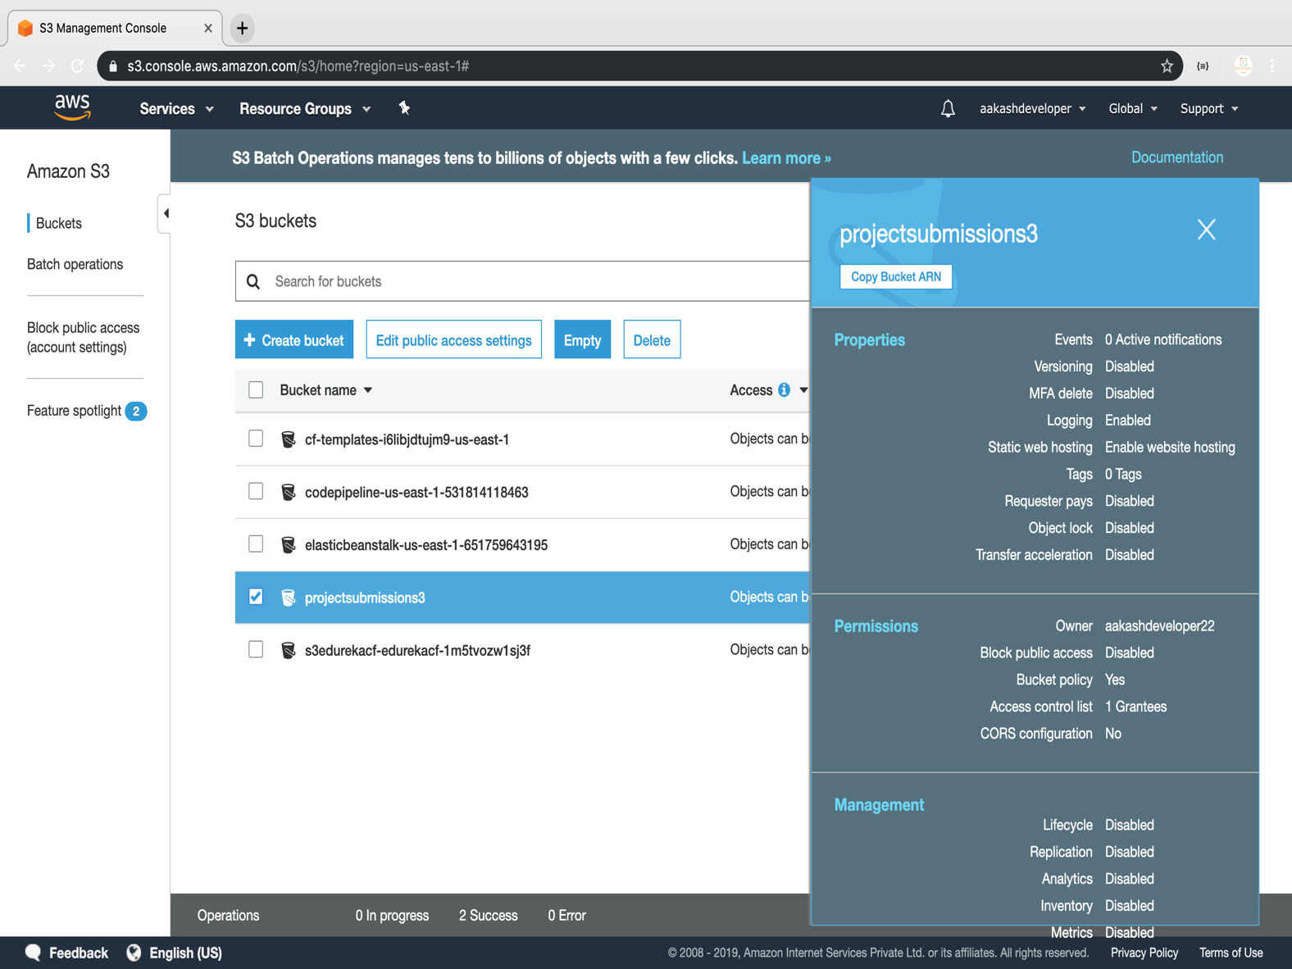

Emptying the bucket

* Verify the content present in the bucket

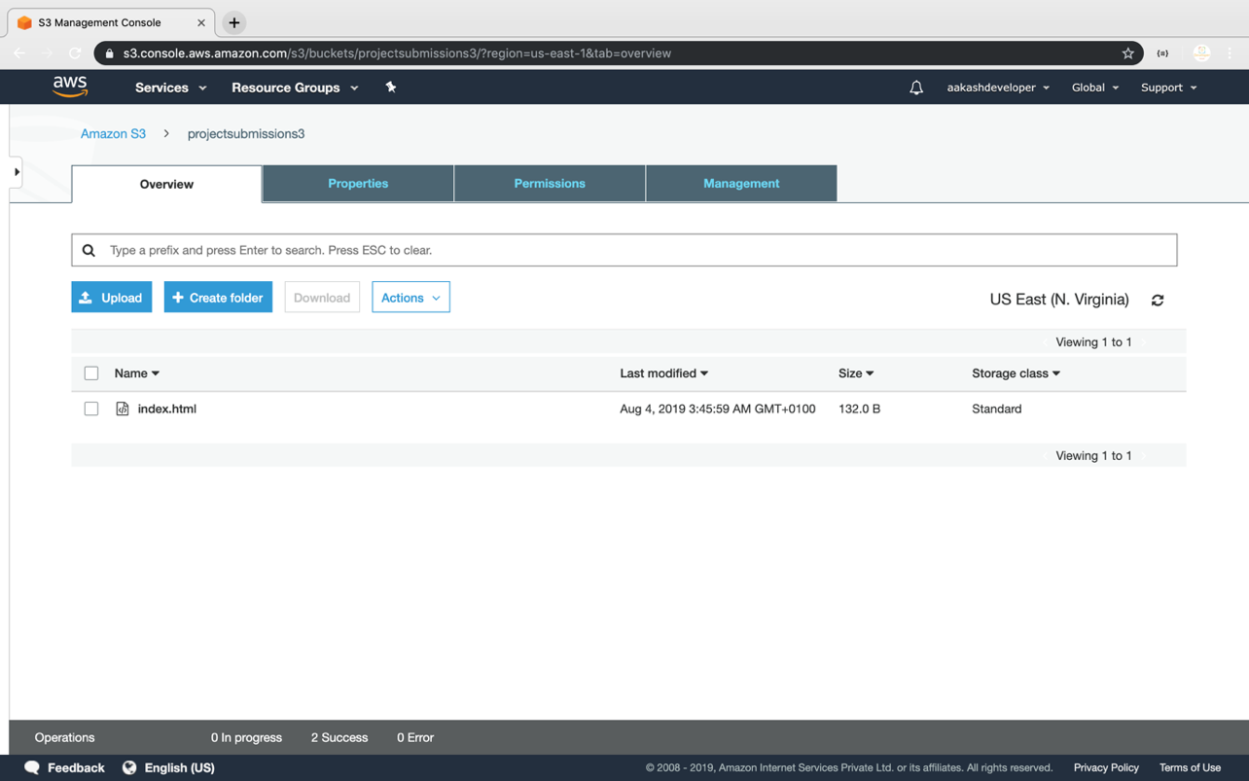

* Empty the bucket

